Participant Name | Phone | Email | Sport
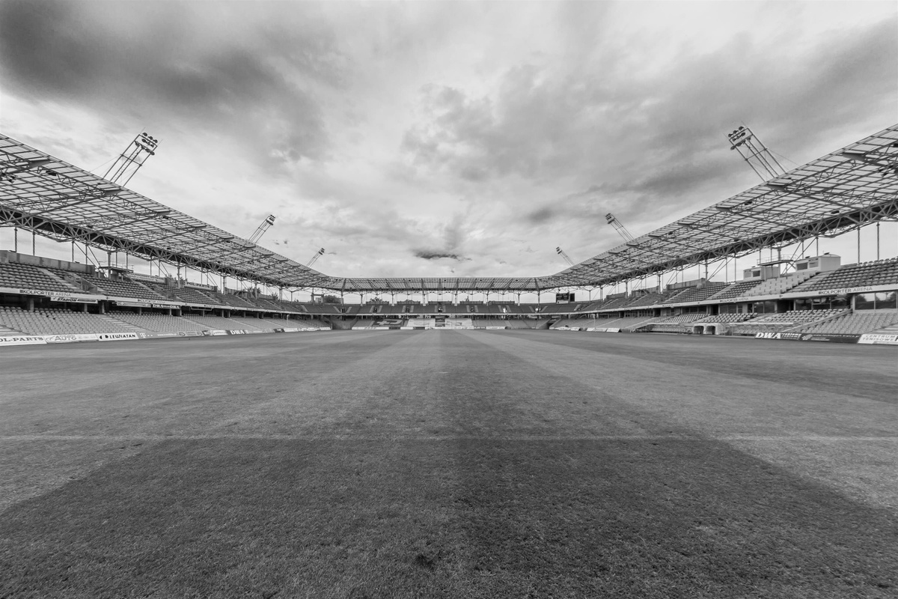
Emily Davis - Organizer | Please contact Emily if you have any questions
+123-456-7890
emily.davis@sportcoordinator.com
SIGN UP SHEET
3 ANYWHERE ST.
GREEN STADIUM
26
May
SUNDAY
3PM—
10PM
SPORTS

