Participant Name | Phone | Email | Sport | Medical Conditions
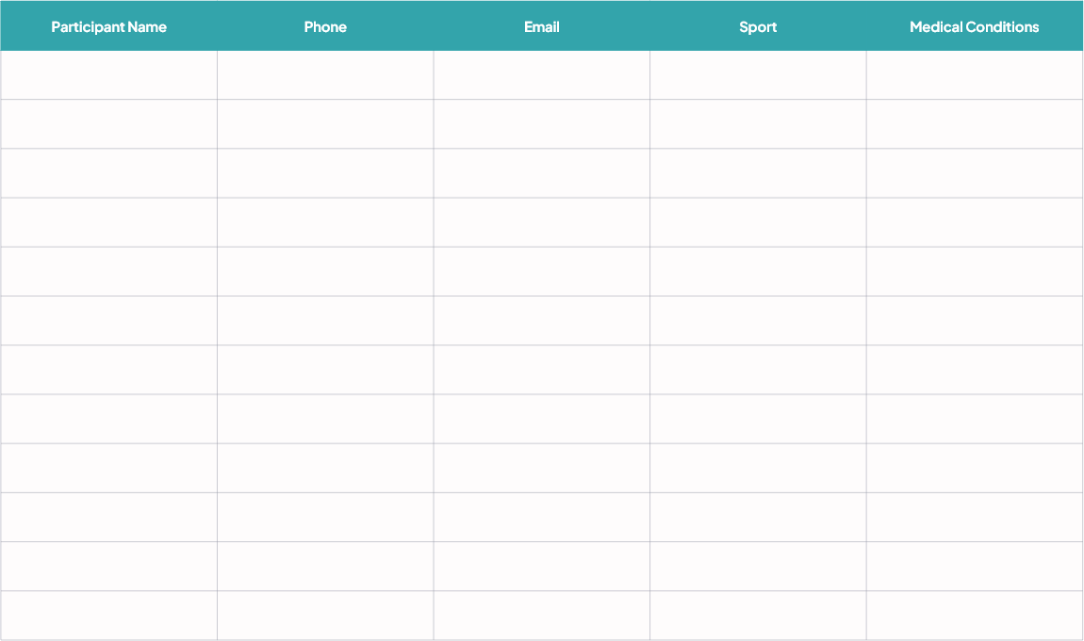
Emily Davis - Organizer | +1 (555) 123-4567 | emily.davis@sportcoordinator.com
Start from 14:00 PM to 20:00 PM
SPORTS
SIGN UP SHEET
FEBRUARY 30, 2030 AT GREENFIELD STADIUM

