FULL NAME | PHONE | DISHES | QUANTITY
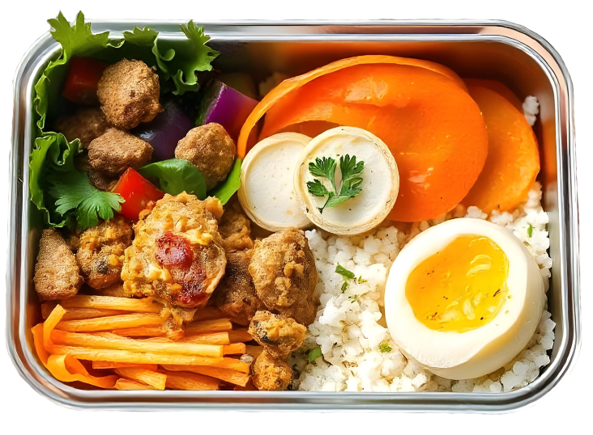
Lunch
Sign up Sheet
Theme | International Cuisine Buffet
Rooftop Garden, Skyline Tower, 15th Floor
April 10, 2024
12:00 PM - 2:00 PM

