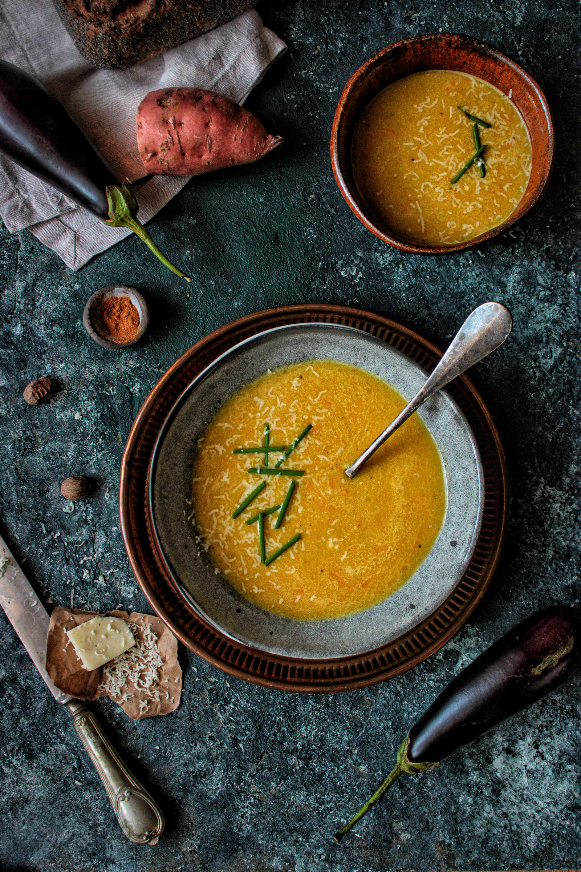
Golden Bowl Banquet Hall, 77 Soup Trail, Broth Haven
2 PM - 6 PM | 16.03.2026
NAME
PHONE
I AM BRINGING
Soup Potluck
Sign up Sheet

