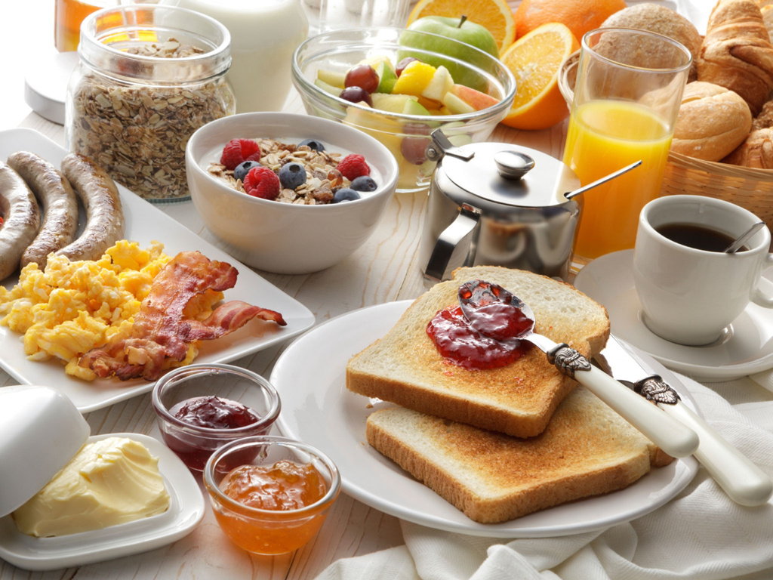
Sunnyvale Community Hall | 145 Brookside Avenue, Sunnyvale, CA 94086
Emily Turner (Organizer) | +123-456-7890
Phone
I am bringing
Full name
Breakfast
25/12
with Chef
Sophia Marie
potluck
SIGN UP SHEET
4 PM

