Organizer's Name | Phone | Email | Date
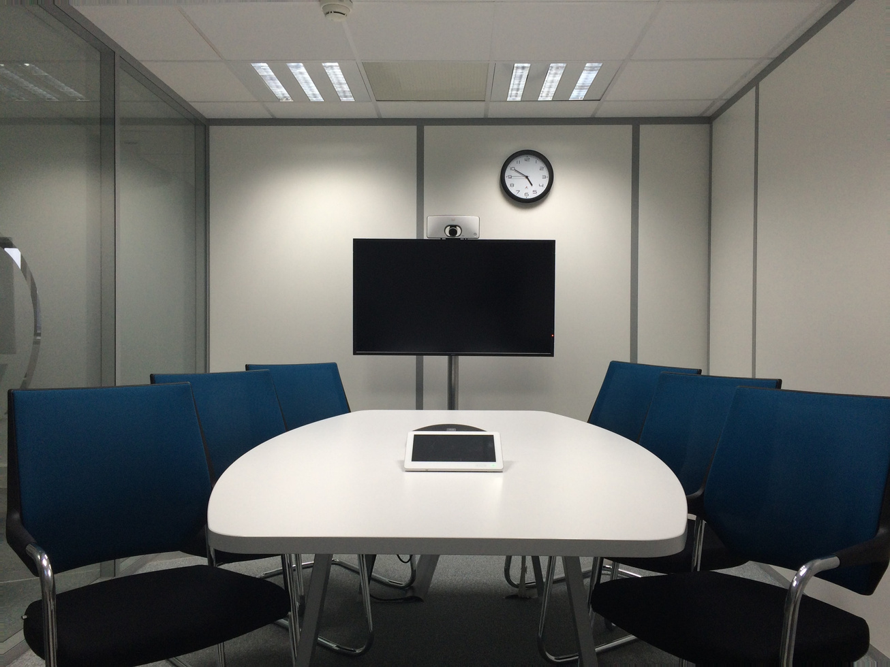
Conference Room
Sign up Sheet
Email
Skylinetowerconferenceroom.com
Hotline
+123-456-7890
Skyline Tower Conference Room
24th Floor, 125 Horizon Avenue, New City, NC 02911

