Participant Name | Phone | Email | Activity Preference | Special Requests
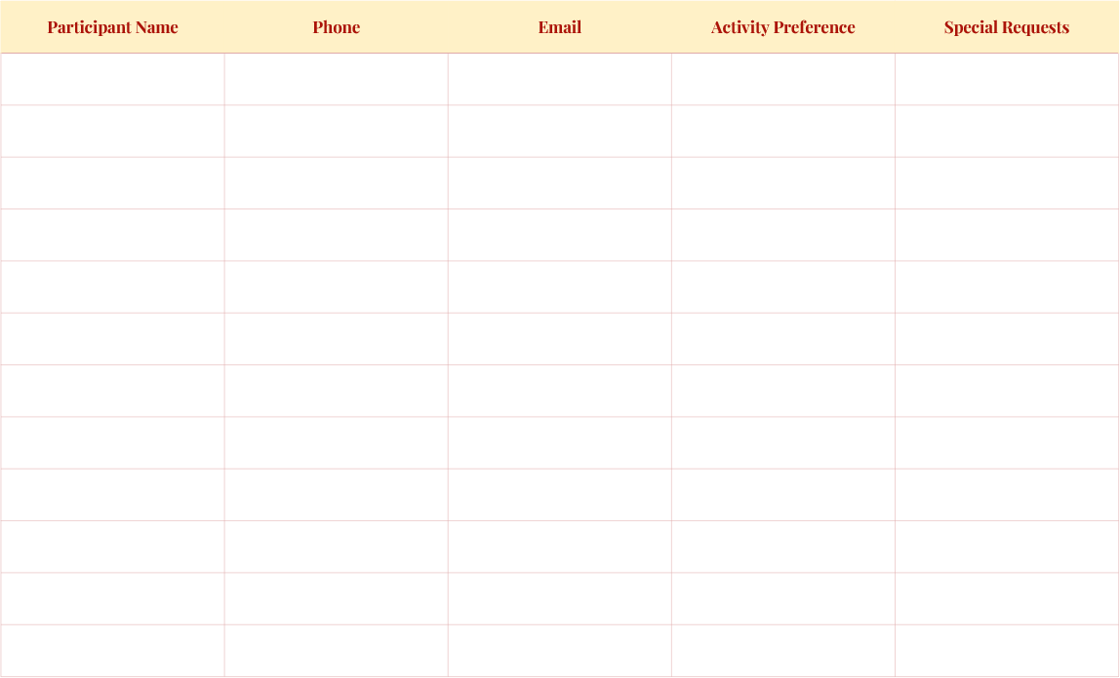
Willow Grove Community Center | 1234 Brookside Lane, Green Valley
Saturday, February 14
12:00 PM - 3:00 PM
Valentines
Sign up Sheet
Don’t be late, or you’ll miss out on a secret surprise waiting just for you. Trust us, it’s unforgettable!
Day

