Participant Name | Phone | Email | Special Requests
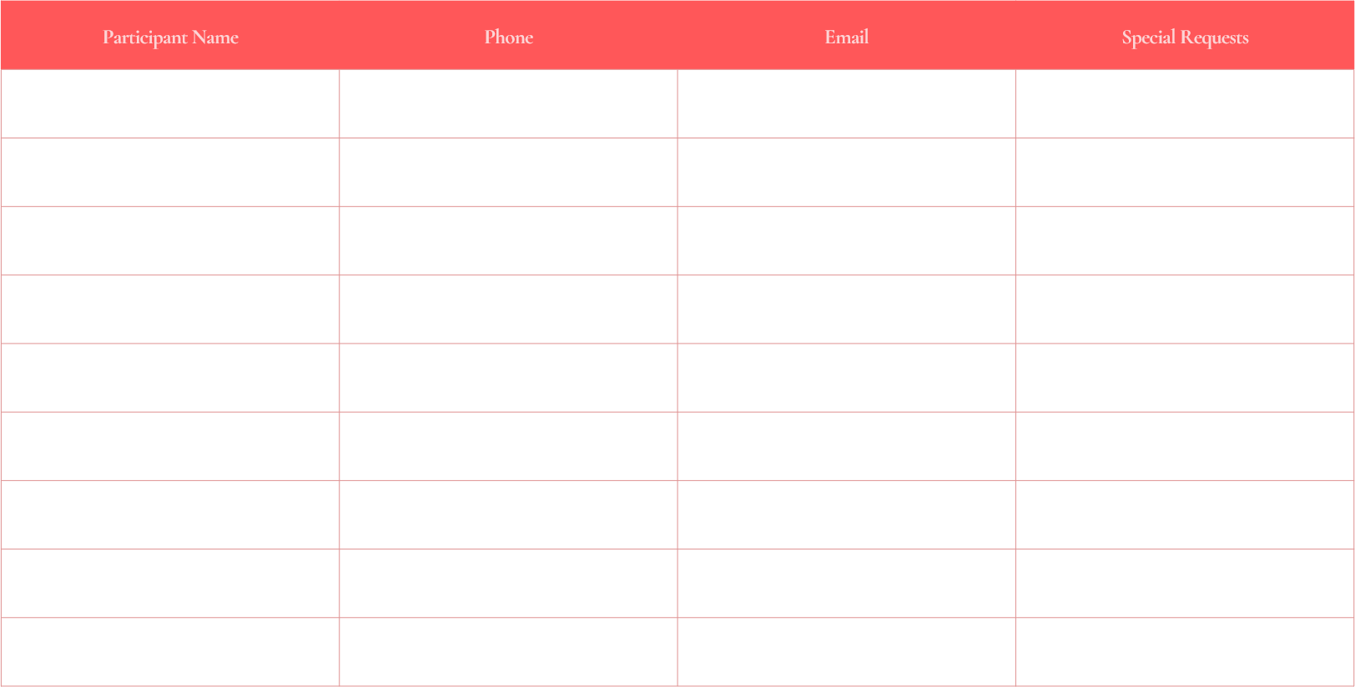
Start from 14:00 to 21:00
Saturday, February 14
Green Valley Sports Complex | 123 Park Avenue, Caryville
Valentines Day
Sign up Sheet

