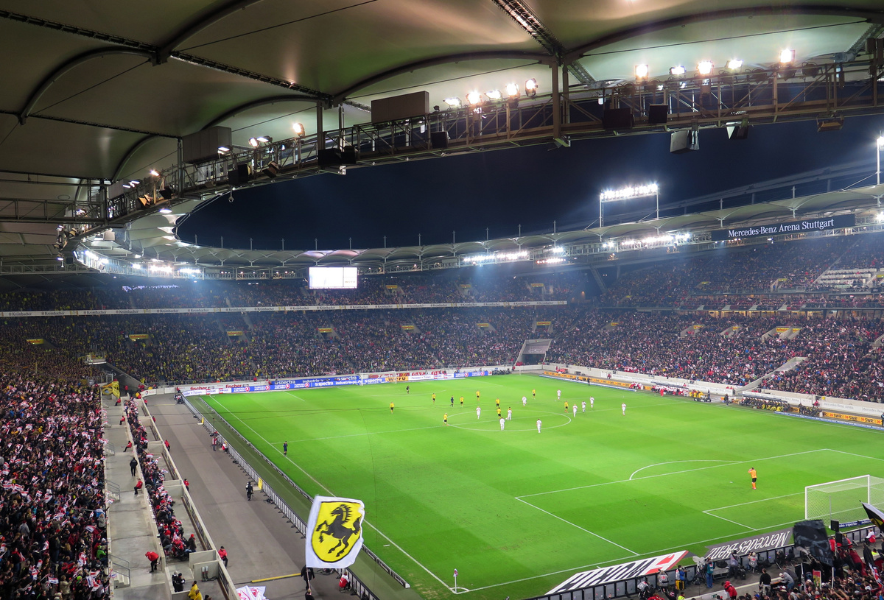
FRIDAY, NOVEMBER 10, FROM 7:00 PM TO 10:00 PM
GECHO VALLEY SPORTS ARENA | 123 PARK AVENUE, NEW YORK, NY
FULL NAME
PHONE
SKILL LEVEL
Tournament
SIGN UP SHEET

