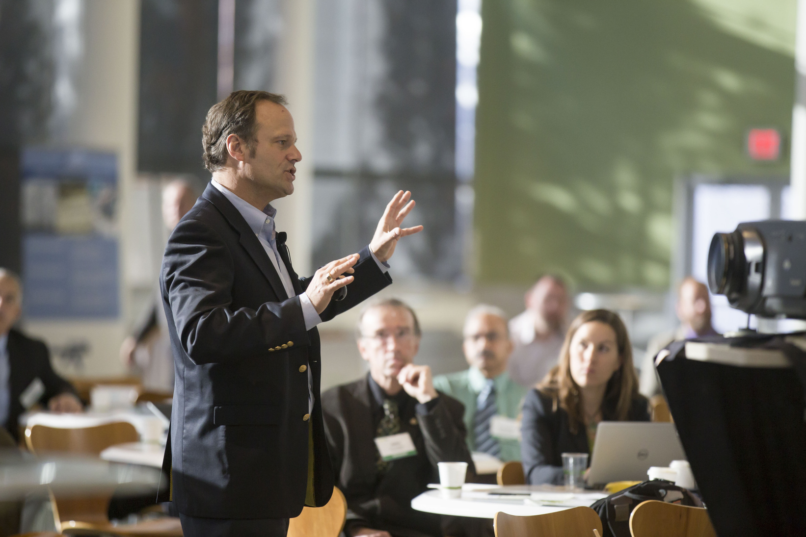
September 15, 2030
Start from 07.00 am - 11.00 am
Grand Hall | 123 River Street, Downtown Riverside, CA
EMAIL
COMPANY NAME
FULL NAME
Conference
Sign up Sheet

